Lab 09

Topic:
- Irvine setup
- Procedure
- Stack operations

Procedure/Functions

Procedure Declaration and Definition in Assembly
In assembly language, a procedure (also called a subroutine or function) is a block of code that performs a specific task. Procedures are useful for modularizing code and avoiding repetition. The Irvine32 library includes built-in procedures like WriteString, but you can also define your own.

Structure of a Procedure
- Declaration: A procedure is declared by giving it a name followed by the keyword PROC.
- Definition: The actual code of the procedure is written between the declaration (PROC) and the termination (ENDP).
- Return: The procedure typically ends with a RET instruction, which tells the CPU to return to the calling code.

Key Elements
- PROC: Marks the beginning of the procedure.
- ENDP: Marks the end of the procedure.
- RET: Returns control to the calling function.
- CALL: The instruction to invoke the procedure.

Simple Example
This example demonstrates a procedure called DisplayMessage that prints a message to the console using the Irvine32 library.

Code Example (main.asm)
INCLUDE Irvine32.inc ; Include the Irvine32 library

.data
message BYTE "Hello from the procedure!", 0 ; Define a message string

.code
main PROC
call DisplayMessage ; Call the DisplayMessage procedure
exit ; Exit the program
main ENDP

; Define the DisplayMessage procedure
DisplayMessage PROC
mov edx, OFFSET message ; Load the address of the message into EDX
call WriteString ; Print the string using Irvine's WriteString procedure
call CrLf ; Move to the next line
ret ; Return to the calling function
DisplayMessage ENDP ; End of the procedure

END main ; End of the program

Stack Applications
There are several important uses of runtime stacks in programs:
  - A stack makes a convenient temporary save area for registers when they are used for more than one purpose. After they are modified, they can be restored to their original values.
  - When the CALL instruction executes, the CPU saves the current subroutine’s return address on the stack.
  - When calling a subroutine, you pass input values called arguments by pushing them on the stack.
  - The stack provides temporary storage for local variables inside subroutines.

PUSH Instruction:
The PUSH instruction first decrements ESP and then copies a source operand into the stack.
A 16-bit operand causes ESP to be decremented by 2. A 32-bit operand causes ESP to be decremented by 4. There are three instruction formats:
PUSH reg/mem16
PUSH reg/mem32
PUSH imm32

POP Instruction:
The POP instruction first copies the contents of the stack element pointed to by ESP into a 16- or
32-bit destination operand and then increments ESP. If the operand is 16 bits, ESP is incremented by 2; if the operand is 32 bits, ESP is incremented by 4:
POP reg/mem16
POP reg/mem32
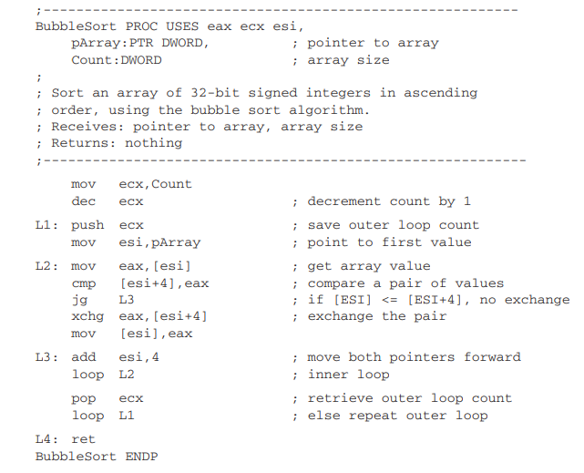

Tasks:

1. Reversing an Array using Stack
- Problem Statement: Write an assembly program to reverse an array of integers using stack operations. Push each element of the array onto the stack and then pop them in reverse order.
- Input: [3, 5, 7, 9, 11]
- Output: [11, 9, 7, 5, 3]
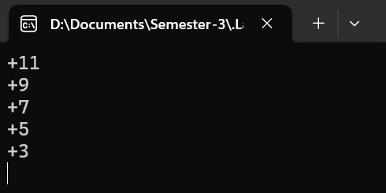
Code:
include irvine32.inc

.DATA
arr db 3, 5, 7, 9, 11
arrs = lengthof arr

.CODE
reverse Proc
mov ecx, arrs
mov esi, offset arr
mov eax, 0

L1:
mov al, byte ptr [esi]
push eax
inc esi
Loop L1

mov ecx, arrs
mov esi, offset arr

L2:
pop [esi]
inc esi
Loop L2

ret
reverse Endp

main Proc
call reverse
mov ecx, arrs
mov edi, 0

L3:
movzx eax, arr[edi] ; Move the address of the string into EDX
call WriteInt ; Call the WriteString procedure to print the string
call CrLf ; Move to the next line after printing
inc edi
Loop L3

exit ; Exit the program

main endp
end main

2. Checking Balanced Parentheses
- Problem Statement: Write an assembly program to check if a string of parentheses is balanced using a stack. For each opening parenthesis (, push it onto the stack, and for each closing parenthesis ), pop from the stack and check if it matches.
- Input: "((())())"
- Output: "Balanced"
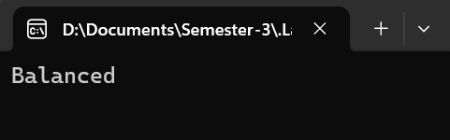
Code:
include irvine32.inc

.DATA
arr db "((())())", 0
str1 db "Balanced", 0
str2 db "Not balanced", 0
br1 = "("
br2 = ")"
bool db 0
temp dd 0

.CODE
isValid Proc
pop temp

mov bl, br1
mov bh, br2
mov dl, 0

mov eax, 0
mov esi, offset arr
mov [esp], dl

cmp [esi], dl
je finish

mov ecx, lengthof arr

L1:
cmp [esi], bl
je J1
jmp else1
J1:
mov al, byte ptr [esi]
push eax
inc esi
jmp skip
else1:

cmp [esi], bh
je J2
jmp else2
J2:
cmp [esp], dl ;if stack is empty
je Jumps
jmp elses
Jumps:
jmp finish
elses:
pop edi

else2:

inc esi
skip:
Loop L1

cmp [esp], dl ;if stack is empty
je J3
jmp else3
J3:
mov bl, 1
mov bool, bl
else3:

finish:

push temp
ret
isValid Endp

main Proc
call isValid

mov dl, 1
cmp bool, dl
je yes
jmp no
yes:
mov edx, offset str1 ; Move the address of the string into EDX
jmp nooo
no:
mov edx, offset str2 ; Move the address of the string into EDX

nooo:
call WriteString ; Call the WriteString procedure to print the string
call CrLf ; Move to the next line after printing

exit ; Exit the program

main endp
end main

3. Palindrome Checker
- Problem Statement: Write an assembly program to check whether a given string is a palindrome. Use the stack to reverse the string and compare it with the original.
- Input: "madam"
- Output: "Palindrome"
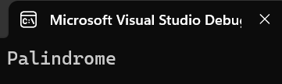
Code:
include irvine32.inc

.DATA
arr db "madam", 0
arrl = lengthof arr - 1
iseven db 0
address dd ?

output1 db "Palindrome", 0
output2 db "Not a palindrome", 0

.CODE
Ispalindrome Proc
pop address
mov eax, 0
mov [esp], eax
mov [esp - 4], eax

; ---Check if length is even or odd---
mov eax, 0
mov edx, 0
mov ax, arrl
mov bx, 2
div bx
mov ebx, eax

cmp edx, 0
je J1
jmp else1
J1:
mov dl, 1
mov iseven, dl
else1:

; Pushing half string
mov ecx, ebx
mov esi, offset arr
mov dx, 0
L1:
mov dl, [esi]
push dx
inc esi
Loop L1

;;;;;
mov dl, 1
cmp iseven, dl
je hehe
inc esi
hehe:

mov ecx, ebx
mov edx, 0
L2:
mov dl, [esi]
cmp dx, [esp]
je J2
jmp else2
J2:
pop dx
else2:
inc esi
Loop L2

mov edx, 0
cmp dx, [esp]
je yes
jmp no
yes:
mov bx, 1
jmp finish
no:
mov bx, 0

finish:
push address
ret
IsPalindrome Endp

main Proc
Call IsPalindrome

mov ax, 0
cmp bx, ax
je nopal

mov edx, offset output1 ; Move the address of the string into EDX
call WriteString ; Call the WriteString procedure to print the string
call CrLf ; Move to the next line after printing
jmp boo

nopal:
mov edx, offset output2 ; Move the address of the string into EDX
call WriteString ; Call the WriteString procedure to print the string
call CrLf ; Move to the next line after printing

boo:

exit ; Exit the program

main endp
end main

4. Evaluating a Postfix Expression
- Problem Statement: Implement a postfix expression evaluator using stack operations. Push operands onto the stack and pop them when encountering an operator to perform calculations.
- Input: "5 6 + 2 *" (Infix notation for (5 + 6) * 2)
- Output: 22
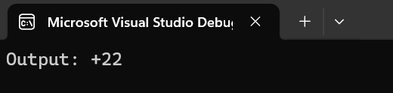
Code:
include irvine32.inc

.DATA
;;arr db "9 2 - 2 / 5 * 7 - 9 - 9 -", 0
arr db "5 6 + 2 *", 0
arrl = lengthof arr - 1
answer dd ?

str1 db "Output: ", 0
address dd ?

.CODE
solvePostfix Proc
pop address
mov eax, 0
mov [esp], eax
mov [esp - 4], eax

mov ecx, arrl
mov ebx, 0
mov esi, offset arr
L1:
mov bl, 20h ;SPACE ' '
cmp [esi], bl
je skip ;if space comes

;Checking for operators
mov bh, "+"
cmp [esi], bh
je operatorhandle
mov bh, "-"
cmp [esi], bh
je operatorhandle
mov bh, "*"
cmp [esi], bh
je operatorhandle
mov bh, "/"
cmp [esi], bh
je operatorhandle
mov bh, "%"
cmp [esi], bh
je operatorhandle

;Push operand
mov ebx, 0
mov bl, [esi]
sub bx, 48
push ebx
jmp skip

operatorhandle:
; '+' ;
cmp bh, "+"
jne minus

pop ebx
pop eax
add eax, ebx
push eax

jmp skip
; '-' ;
minus:
cmp bh, "-"
jne multiply

pop ebx
pop eax
sub eax, ebx
push eax

jmp skip
; '*' ;
multiply:
cmp bh, "*"
jne divide

pop ebx
pop eax
mul ebx
push eax

jmp skip
; '/' ;
divide:
cmp bh, "/"
jne modulus

mov edx, 0
pop ebx
pop eax
div ebx
push eax

jmp skip
; '%' ;
modulus:
cmp bh, "%"
jne skip

mov edx, 0
pop ebx
pop eax
div ebx
;mov al, ah
;mov ah, 0
push edx

jmp skip
skip:
inc esi

dec ecx
cmp ecx, 0
jne L1
;Loop L1

mov eax, [esp]
mov answer, eax

push address
ret
solvePostfix Endp

main Proc
call solvePostfix

mov edx, offset str1 ; Move the address of the string into EDX
call WriteString ; Call the WriteString procedure to print the string

mov eax, answer ; Move the address of the string into EDX
call WriteInt ; Call the WriteString procedure to print the string
call CrLf ; Move to the next line after printing

exit ; Exit the program

main endp
end main

5. Sorting an Array using Stack (Bubble Sort)
- Problem Statement: Use stack operations (PUSH and POP) to simulate swapping in a Bubble Sort algorithm to sort an array.
- Input: [8, 4, 3, 7, 6]
- Output: [3, 4, 6, 7, 8]
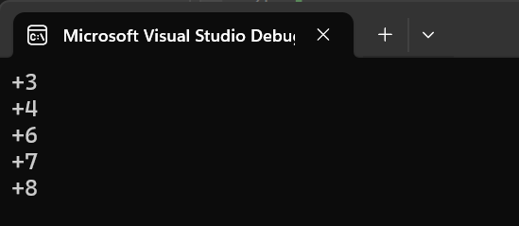
Code:
include irvine32.inc

.DATA
arr dw 8, 4, 3, 7, 6

address dd ?

.CODE
bubblesort Proc

AgainWeGo:
mov cx, 0
mov [ebp+4], cx ;Reset swap local var to 0
dec dword ptr [ebp+8] ;decreasing size
mov esi, [ebp+12] ;moving address of array
mov ebx, 0 ;initialize array index to zero
Loop1:
mov ax,[esi] ;load number to ax
cmp ax,[esi+2] ;compare with next number
jle noswap ;no swap if already inorder

mov dx,[esi+2] ;load second element in dx
mov [esi+2],ax ;store first number in second
mov [esi],dx ;store second number in first
mov dword ptr [ebp+4], 1 ;flag that a swap has been done
noswap:
inc bx ;advance bx to next index
add esi, 2 ;incrementing pointer
cmp bx, [ebp+8] ;are we at last index
jne loop1 ;if not than compare next 2

cmp dword ptr [ebp+4],1 ;check if swap has been done
je AgainWeGo ;if yes than make another pass

ret 8
bubblesort Endp

main Proc
mov eax, 0
push offset arr
push lengthof arr
sub esp, 4
push ebp
mov ebp, esp

call bubblesort
add esp, 8

mov ecx, lengthof arr
mov edi, 0
L3:
movzx eax, arr[edi] ; Move the address of the string into EDX
call WriteInt ; Call the WriteString procedure to print the string
call CrLf ; Move to the next line after printing
add edi, 2
Loop L3

exit ; Exit the program

main endp
end main

6. Infix to Postfix Conversion
- Problem Statement: Convert an infix expression (e.g., 3 + 4 * 2) to postfix notation (e.g., 3 4 2 * +) using stack operations.
- Input: "3 + 4 * 2"
- Output: "3 4 2 * +"
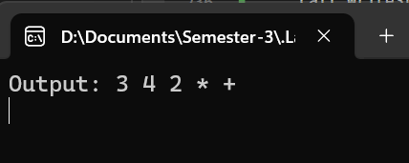
include irvine32.inc

.DATA
arr db "3 + 4 * 2", 0
arrl = lengthof arr - 1
outarr db arrl dup(?), 0
temp db 30 dup(0)

str1 db "Output: ", 0
address dd ?

.CODE
convert Proc
pop address
mov eax, 0
mov [esp], eax
mov [esp - 4], eax

mov ecx, arrl
mov ebx, 0
mov esi, offset arr
mov edi, offset outarr
mov ebp, -1
L1:
;Checking for operators
mov bh, "+"
cmp [esi], bh
je operatorhandle
mov bh, "-"
cmp [esi], bh
je operatorhandle
mov bh, "*"
cmp [esi], bh
je operatorhandle
mov bh, "/"
cmp [esi], bh
je operatorhandle
mov bh, "%"
cmp [esi], bh
je operatorhandle

;Cancatenate operand
mov bl, [esi]
mov [edi], bl
inc edi
jmp skip

operatorhandle:
inc esi
dec ecx
; '+' ;
cmp bh, "+"
jne minus

mov dh, "-"
cmp [esp], dh
je equalprecltr
mov dh, "*"
cmp [esp], dh
je lowerprec
mov dh, "/"
cmp [esp], dh
je lowerprec
mov dh, "%"
cmp [esp], dh
je lowerprec

jmp higherprec

jmp skip
; '-' ;
minus:
cmp bh, "-"
jne multiply

mov dh, "+"
cmp [esp], dh
je equalprecltr
mov dh, "*"
cmp [esp], dh
je lowerprec
mov dh, "/"
cmp [esp], dh
je lowerprec
mov dh, "%"
cmp [esp], dh
je lowerprec

jmp higherprec

jmp skip
; '*' ;
multiply:
cmp bh, "*"
jne divide

mov dh, "+"
cmp [esp], dh
je higherprec
mov dh, "-"
cmp [esp], dh
je higherprec
mov dh, "/"
cmp [esp], dh
je equalprecltr
mov dh, "%"
cmp [esp], dh
je equalprecltr

jmp higherprec

jmp skip
; '/' ;
divide:
cmp bh, "/"
jne modulus

mov dh, "+"
cmp [esp], dh
je higherprec
mov dh, "-"
cmp [esp], dh
je higherprec
mov dh, "*"
cmp [esp], dh
je equalprecltr
mov dh, "%"
cmp [esp], dh
je equalprecltr

jmp higherprec

jmp skip
; '%' ;
modulus:
cmp bh, "%"
jne skip

mov dh, "+"
cmp [esp], dh
je higherprec
mov dh, "-"
cmp [esp], dh
je higherprec
mov dh, "/"
cmp [esp], dh
je equalprecltr
mov dh, "*"
cmp [esp], dh
je equalprecltr

jmp higherprec

;;;;;;;;;;;
higherprec:
cmp ebp, -1
jne lowerprec2

mov bl, bh
mov bh, 0
push bx
jmp skip

;;;;;;;;;;;
lowerprec:
pop dx
inc ebp
mov temp[ebp], dl

jmp operatorhandle
jmp skip

lowerprec2:
mov bl, bh
mov bh, 0
push bx

mov bx, 0
mov bl, temp[ebp]
mov [edi], bx
dec ebp

cmp ebp, -1
jne lowerprec2
jmp skip

;;;;;;;;;;;;;
equalprecltr:
pop dx
inc ebp
mov temp[ebp], dl

mov bl, bh
mov bh, 0
push bx

jmp skip

skip:
inc esi
dec ecx
cmp ecx, 0
jne L1
;Loop L1

;;;Cancatenate all stack
canst:
mov dx, [esp]
cmp dx, 0
je theend
mov dx, 20h
mov [edi], dx
inc edi
pop dx
mov [edi], dx
inc edi
jmp canst

theend:
mov eax, [esp]

push address
ret
convert Endp

main Proc
call convert

mov edx, offset str1 ; Move the address of the string into EDX
call WriteString ; Call the WriteString procedure to print the string

mov edx, offset outarr ; Move the address of the string into EDX
call WriteString ; Call the WriteString procedure to print the string
call CrLf ; Move to the next line after printing

exit ; Exit the program

main endp
end main

7. Implementing a Stack Using Arrays
- Problem Statement: Simulate a stack data structure using an array. Implement the basic stack operations: PUSH, POP, PEEK, and DISPLAY.
- Input: Push: 3, Push: 5, Pop, Push: 9
- Output: [3, 9]
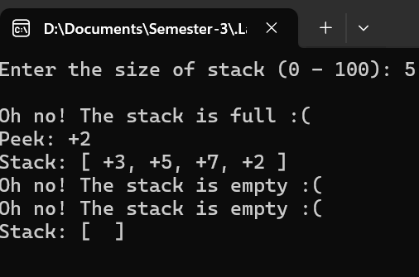
Code:
include irvine32.inc

.DATA
arr dw 101 dup(?)
arrsize dw ?
inputval dw ?

str1 db "Enter the size of stack (0 - 100): ", 0
str2 db "Out of range... Enter again (0 - 100): ", 0
emptymess db "Oh no! The stack is empty :( ", 0
fullmess db "Oh no! The stack is full :( ", 0
disp1 db "Stack: [ ", 0
disp2 db ", ", 0
disp3 db " ]", 0
peek1 db "Peek: ", 0

.CODE
CreateStack Proc
mov eax, offset arr - 2
mov ebp, eax

;Message
mov edx, offset str1 ; Move the address of the string into EDX
call WriteString ; Call the WriteString procedure to print the string
jmp TakeInput

AgainMessage:
mov edx, offset str2 ; Move the address of the string into EDX
call WriteString ; Call the WriteString procedure to print the string

TakeInput:
mov eax, 0
mov ax, arrsize
call ReadInt
mov arrsize, ax
call CrLf

;----- Input Validation -----
cmp arrsize, bx
jl AgainMessage
cmp arrsize, cx
jg AgainMessage

ret
CreateStack Endp

IsFull Proc
mov dx, 0
mov eax, offset arr
mov ebx, 0
mov bx, arrsize ;Only length
dec bx ;L-1
add bx, bx ;(L-1)*type arr (bx*2)
add eax, ebx

cmp ebp, eax
jne notfull
mov dx, 1

notfull:

ret
IsFull Endp

IsEmpty Proc
mov dx, 0
mov eax, offset arr
sub eax, 2

cmp ebp, eax
jne notempty
mov dx, 1

notempty:

ret
IsEmpty Endp

Pushst Proc
Call isFull
cmp dx, 1
je itsfull
add ebp, 2
mov dx, inputval
mov [ebp], dx
jmp ohh
itsfull:
mov edx, offset fullmess
call WriteString
call CrLf

ohh:
ret
Pushst Endp

Popst Proc
Call isEmpty
cmp dx, 1
je itsempty
sub ebp, 2
jmp yaaay
itsempty:
mov edx, offset emptymess
call WriteString
call CrLf

yaaay:
ret
Popst Endp

Peekst Proc
Call isEmpty
cmp dx, 1
je itsempty
mov edx, offset peek1
Call WriteString

mov eax, 0
mov ax, [ebp]
call WriteInt
call CrLf
jmp yaay
itsempty:
mov edx, offset emptymess
call WriteString
call CrLf

yaay:
ret
Peekst Endp

Display Proc
mov edx, 0
mov eax, 0
mov edi, offset arr

mov edx, offset disp1
Call WriteString

Call isEmpty
cmp dx, 1
je itsempty
mov eax, 0

PrintL:
mov ax, [edi]
Call WriteInt

cmp edi, ebp
je Exitploop

mov edx, offset disp2
Call WriteString

add edi, 2
jmp PrintL
Exitploop:

itsempty:
mov edx, offset disp3
Call WriteString
Call CrLf

ret
Display Endp

main Proc
mov bx, 0
mov cx, 100

Call CreateStack

mov bx, 3
mov inputval, bx
Call Pushst

mov bx, 5
mov inputval, bx
Call Pushst

mov bx, 7
mov inputval, bx
Call Pushst

mov bx, 6
mov inputval, bx
Call Pushst

mov bx, 4
mov inputval, bx
Call Pushst

mov bx, 2
mov inputval, bx
Call Pushst

Call Popst
Call Popst

mov bx, 2
mov inputval, bx
Call Pushst

Call Peekst

Call Display

Call Popst
Call Popst
Call Popst
Call Popst
Call Popst

Call Peekst

Call Display

exit ; Exit the program

main endp
end main

8. Finding the Maximum Element in a Stack
- Problem Statement: Write a program that finds the maximum element in a stack. After pushing all elements, pop them to check the maximum value.
- Input: [2, 9, 4, 6, 1]
- Output: 9
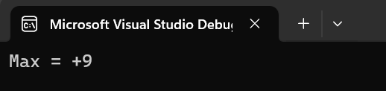
Code:
include irvine32.inc

.DATA
str1 db "Max = ", 0
arr db 2, 9, 4, 6
arrl = lengthof arr
max db ?
temp dd ?
address dd ?

.CODE
Findmax Proc
pop address

mov esi, offset arr
mov ecx, arrl
L1:
mov eax, 0
mov al, [esi]
push eax
inc esi
Loop L1

mov ah, [esp]

;Largest find
mov ecx, lengthof arr
L2:
pop temp
mov ebx, temp

cmp bl, ah
jg J1
jmp else1
J1:
mov ah, bl
else1:

Loop L2
mov max, ah

push address
ret
Findmax Endp

main Proc
call Findmax

mov edx, offset str1 ; Move the address of the string into EDX
call WriteString
movzx eax, max ; Move the address of the string into EDX
call WriteInt ; Call the WriteString to print the string
call CrLf ; Move to the next line after printing

exit ; Exit the program

main endp
end main

9. Checking Stack Overflow and Underflow
- Problem Statement: Implement a stack with a fixed size using an array. The program should check for stack overflow (when pushing an element onto a full stack) and stack underflow (when popping from an empty stack).
- Input: Stack size = 5, push 6 elements
- Output: "Stack Overflow"
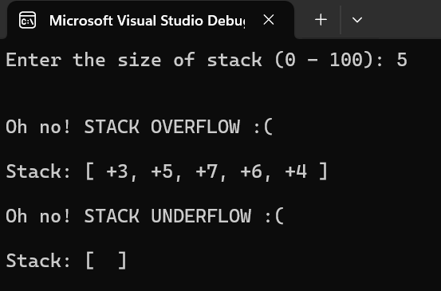
Code:
include irvine32.inc

.DATA
arr dw 101 dup(?)
arrsize dw ?
inputval dw ?

str1 db "Enter the size of stack (0 - 100): ", 0
str2 db "Out of range... Enter again (0 - 100): ", 0
emptymess db "Oh no! STACK UNDERFLOW :( ", 0
fullmess db "Oh no! STACK OVERFLOW :( ", 0
disp1 db "Stack: [ ", 0
disp2 db ", ", 0
disp3 db " ]", 0
peek1 db "Peek: ", 0

.CODE
CreateStack Proc
mov eax, offset arr - 2
mov ebp, eax

;Message
mov edx, offset str1 ; Move the address of the string into EDX
call WriteString ; Call the WriteString procedure to print the string
jmp TakeInput

AgainMessage:
mov edx, offset str2 ; Move the address of the string into EDX
call WriteString ; Call the WriteString procedure to print the string

TakeInput:
mov eax, 0
mov ax, arrsize
call ReadInt
mov arrsize, ax
call CrLf

;----- Input Validation -----
cmp arrsize, bx
jl AgainMessage
cmp arrsize, cx
jg AgainMessage

ret
CreateStack Endp

IsFull Proc
mov dx, 0
mov eax, offset arr
mov ebx, 0
mov bx, arrsize
dec bx
add bx, bx
add eax, ebx

cmp ebp, eax
jne notfull
mov dx, 1

notfull:

ret
IsFull Endp

IsEmpty Proc
mov dx, 0
mov eax, offset arr
sub eax, 2

cmp ebp, eax
jne notempty
mov dx, 1

notempty:

ret
IsEmpty Endp

Pushst Proc
Call isFull
cmp dx, 1
je itsfull
add ebp, 2
mov dx, inputval
mov [ebp], dx
jmp ohh
itsfull:
Call CrLf
mov edx, offset fullmess
call WriteString
call CrLf

ohh:
ret
Pushst Endp

Popst Proc
Call isEmpty
cmp dx, 1
je itsempty
sub ebp, 2
jmp yaaay
itsempty:
Call CrLf
mov edx, offset emptymess
call WriteString
call CrLf

yaaay:
ret
Popst Endp

Peekst Proc
Call isEmpty
cmp dx, 1
je itsempty
mov edx, offset peek1
Call WriteString

mov eax, 0
mov ax, [ebp]
call WriteInt
call CrLf
jmp yaay
itsempty:
Call CrLf
mov edx, offset emptymess
call WriteString
call CrLf

yaay:
ret
Peekst Endp

Display Proc
mov edx, 0
mov eax, 0
mov edi, offset arr

Call CrLf
mov edx, offset disp1
Call WriteString

Call isEmpty
cmp dx, 1
je itsempty
mov eax, 0

PrintL:
mov ax, [edi]
Call WriteInt

cmp edi, ebp
je Exitploop

mov edx, offset disp2
Call WriteString

add edi, 2
jmp PrintL
Exitploop:

itsempty:
mov edx, offset disp3
Call WriteString
Call CrLf

ret
Display Endp

main Proc
mov bx, 0
mov cx, 100

Call CreateStack

mov bx, 3
mov inputval, bx
Call Pushst

mov bx, 5
mov inputval, bx
Call Pushst

mov bx, 7
mov inputval, bx
Call Pushst

mov bx, 6
mov inputval, bx
Call Pushst

mov bx, 4
mov inputval, bx
Call Pushst

mov bx, 2
mov inputval, bx
Call Pushst

Call Display

Call Popst
Call Popst
Call Popst
Call Popst
Call Popst
Call Popst

Call Display

exit ; Exit the program

main endp
end main

10. Reverse a String using Stack
- Problem Statement: Write a program to reverse a string using stack operations. Push each character onto the stack and then pop them in reverse order to form the reversed string.
- Input: "hello"
- Output: "ello"
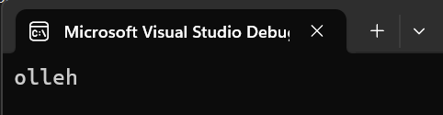
Code:
include irvine32.inc

.DATA
arr db "hello", 0
arrs = lengthof arr - 1

.CODE
reverse Proc
mov ecx, arrs
mov esi, offset arr
mov eax, 0

L1:
mov al, byte ptr [esi]
push eax
inc esi
Loop L1

mov ecx, arrs
mov esi, offset arr

L2:
pop [esi]
inc esi
Loop L2

ret
reverse Endp

main Proc
call reverse
mov ecx, arrs
mov edi, 0

mov edx, offset arr ; Move the address of the string into EDX
call WriteString ; Call the WriteString procedure to print the string
call CrLf ; Move to the next line after printing

exit ; Exit the program

main endp
end main

